Phase 3: Data Modeling & Relationships

1. Introduction
Phase 3 focuses on designing the data architecture of the Salesforce project. Proper data modeling ensures accurate tracking of business processes, seamless integration with automation, and correct reporting.
Objectives:
- Create standard and custom objects.
- Define fields, relationships, record types, and page layouts.
- Configure lookup, master-detail, and junction objects.
- Design data model for Partner Orders, Products, Inventory, and Order Line Items.

2. Standard & Custom Objects

2.1 Standard Objects
- Leveraged Salesforce standard objects for basic functionality:
  - Account – Used for Distributors and Partners.
  - Contact – For partner representatives.

2.2 Custom Objects
- Created custom objects for project-specific requirements:
  - Product__c – Stores product catalog details.
  - Inventory__c – Tracks available inventory per product.
  - Partner_Order__c – Captures partner orders.
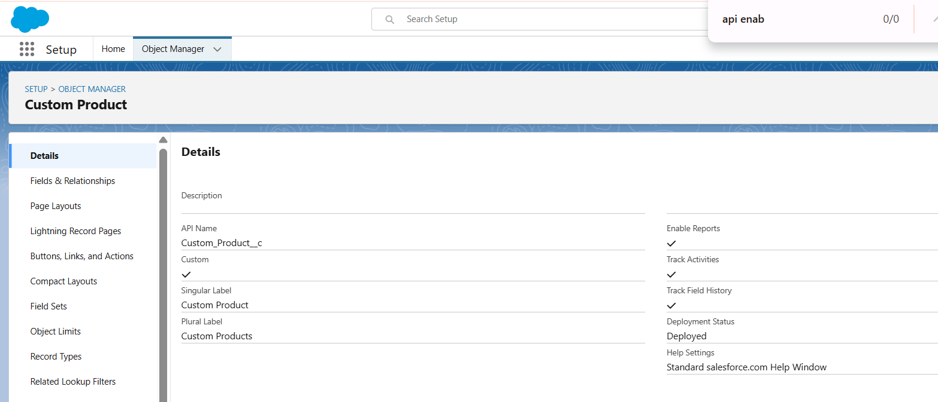
  - Order_Line_Item__c – Line items for each order.

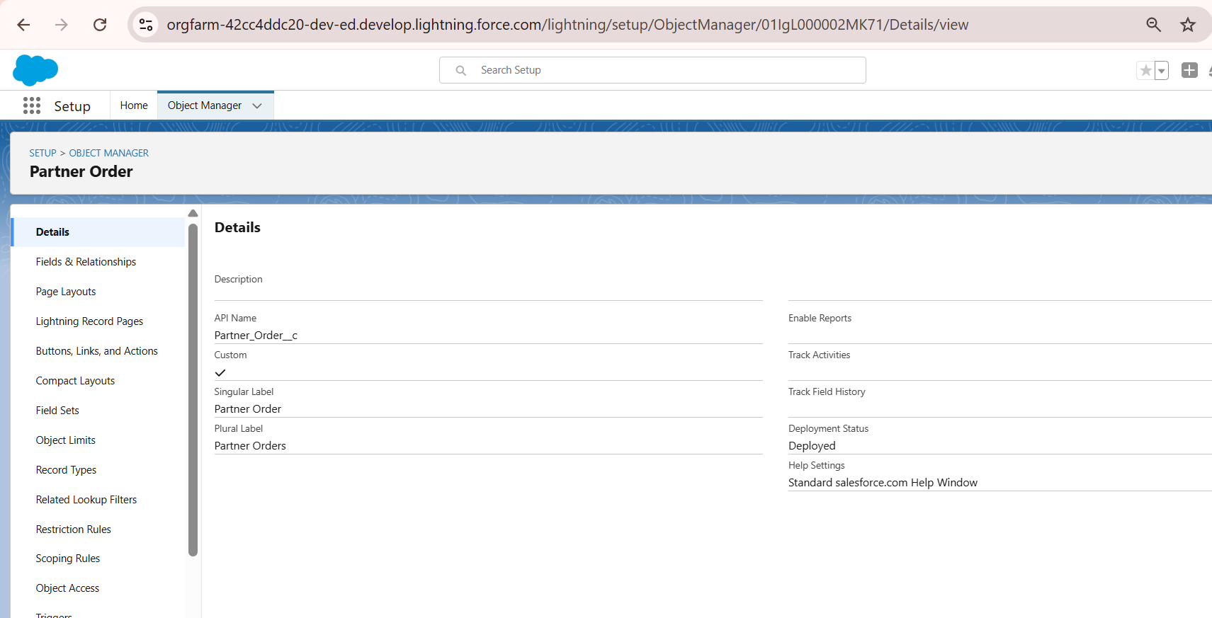
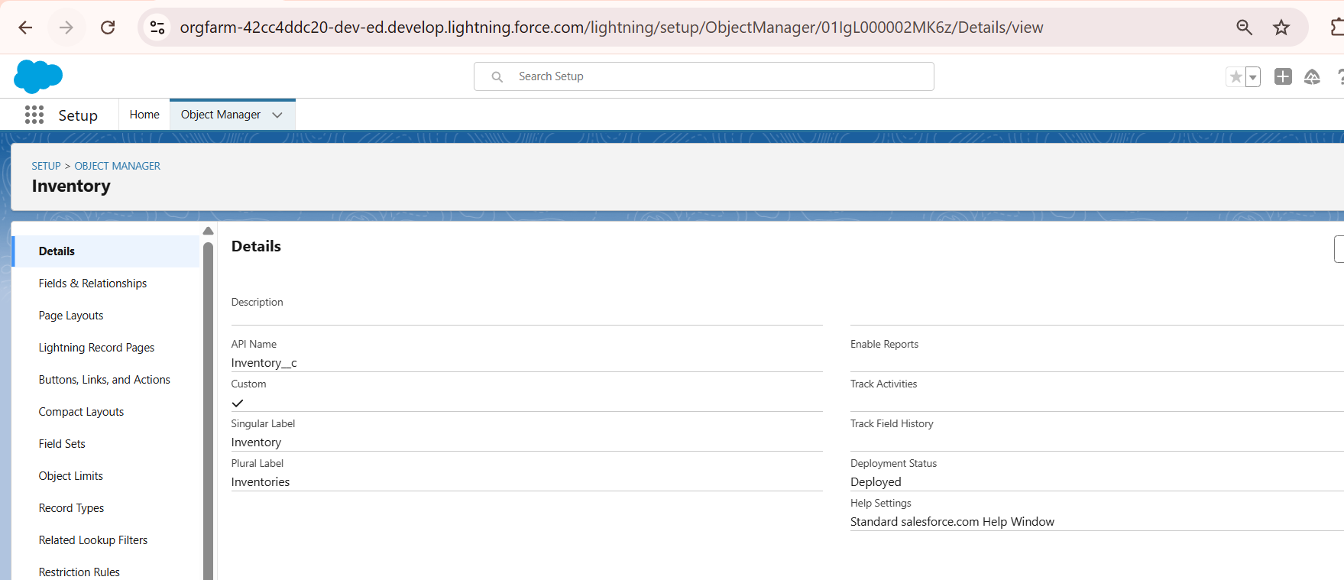
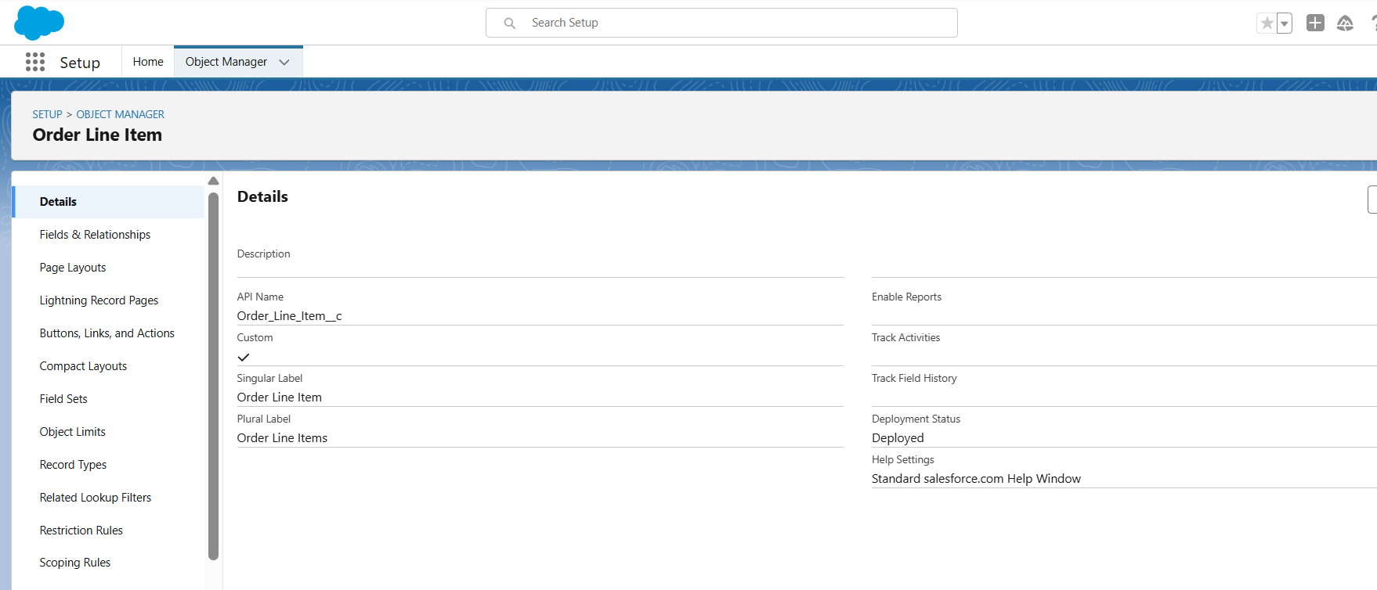

3. Custom Fields
- Created fields for each custom object with appropriate data types:
Object | Field | Type | Description
Product__c | Name | Text | Product name
Product__c | SKU__c | Text | Product SKU code
Product__c | Price__c | Currency | Product price
Inventory__c | Product__c | Lookup(Product__c) | Product associated with inventory
Inventory__c | QuantityAvailable__c | Number | Available stock
Partner_Order__c | Distributor__c | Lookup(Account) | Distributor placing the order
Partner_Order__c | Total_Amount__c | Currency | Total order value
Order_Line_Item__c | Partner_Order__c | Master-Detail(Partner_Order__c) | Parent order
Order_Line_Item__c | Product__c | Lookup(Product__c) | Product for line item
Order_Line_Item__c | Quantity__c | Number | Quantity ordered
Order_Line_Item__c | UnitPrice__c | Currency | Price per unit
- Object Manager → Product__c → Fields & Relationships.
- Show newly created fields with data types.
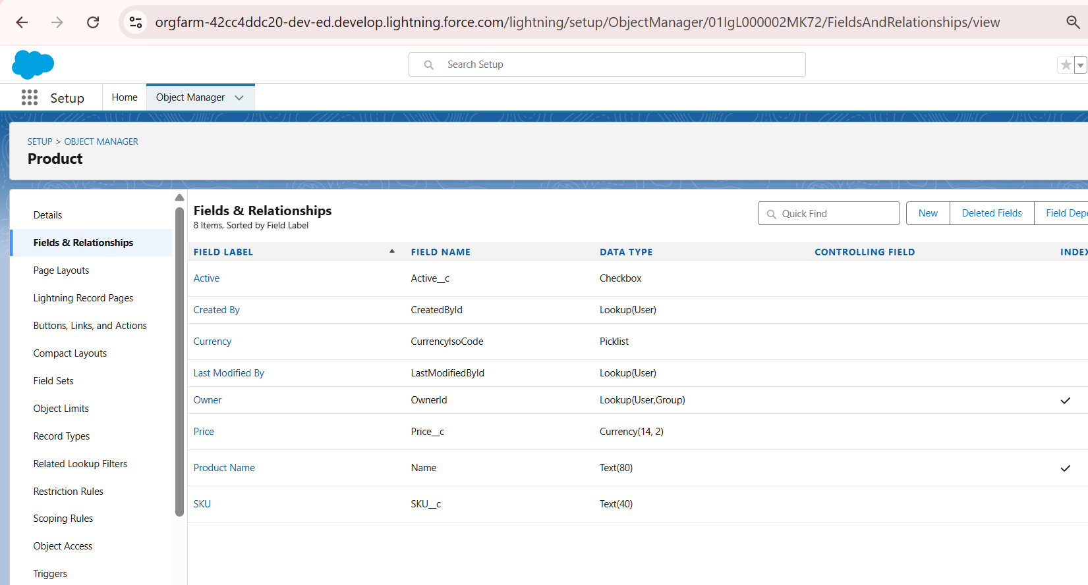

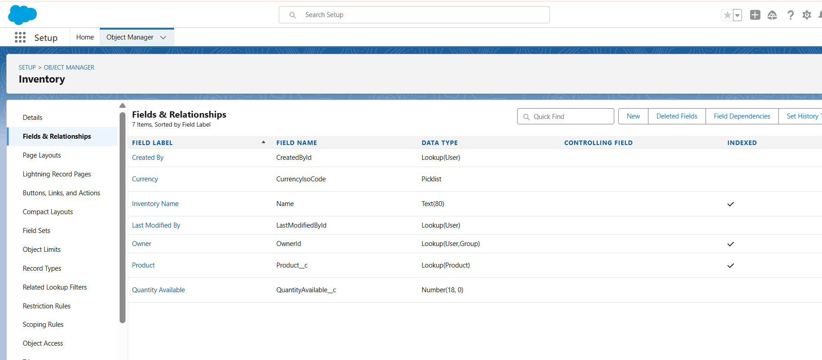

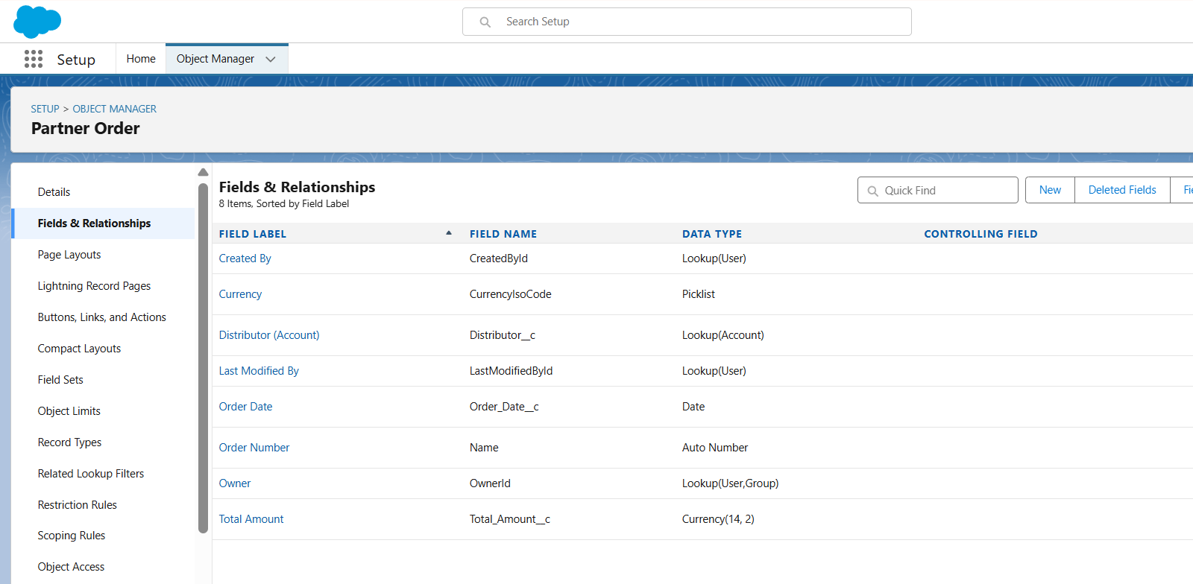
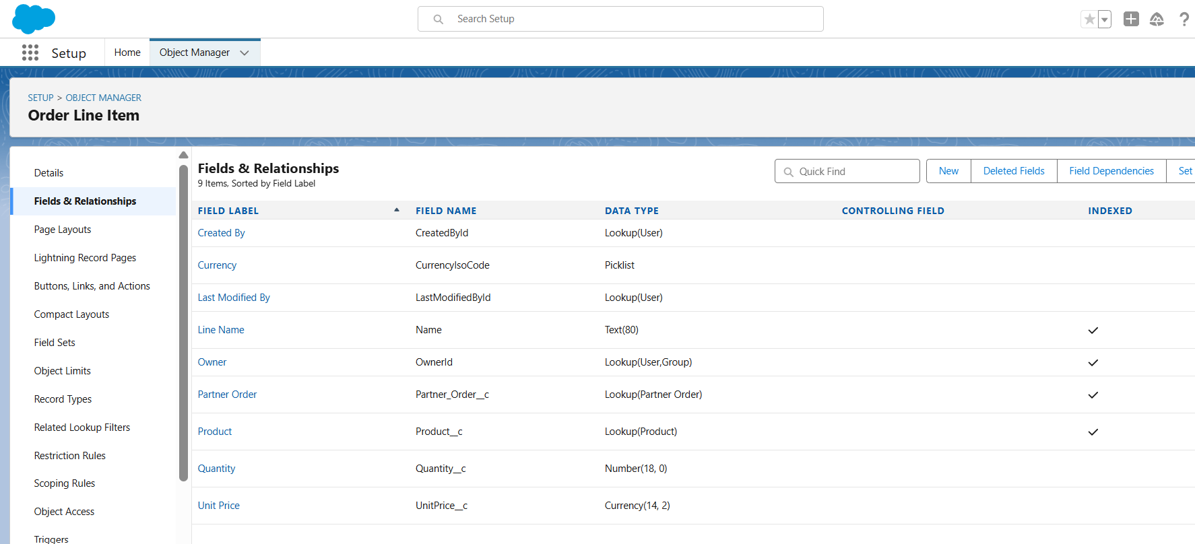

4. Record Types & Page Layouts

4.1 Record Types
- Created record types to differentiate between Distributor Orders and Partner Orders.
- Assigned appropriate page layouts and picklist values for each record type.

4.2 Page Layouts
- Customized layouts for each object to improve user experience:
  - Moved critical fields to top section.
  - Added related lists (Order Line Items under Partner Orders).

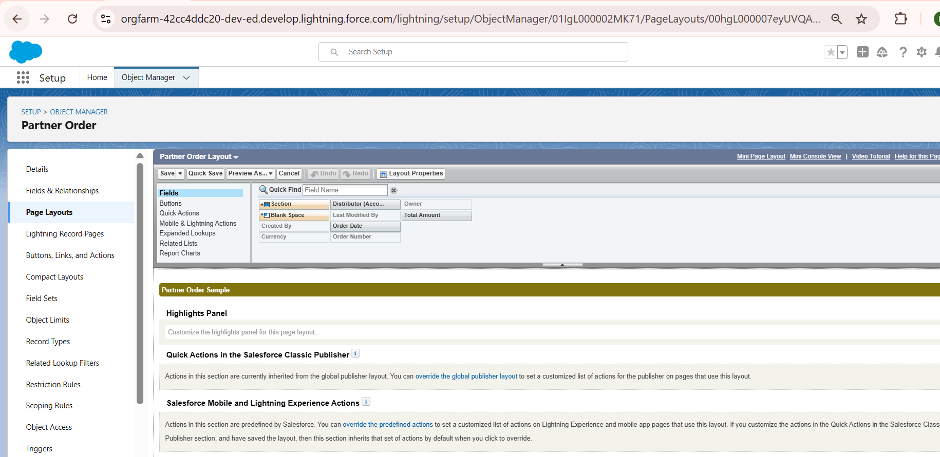4.3 Compact Layouts
- Designed compact layouts for record previews in Lightning Experience.
- Displayed key fields such as Distributor Name, Total Amount, and Order Date.

5. Relationships

5.1 Lookup vs Master-Detail
- Lookup Relationship: Inventory → Product (optional relationship, records can exist independently).
- Master-Detail Relationship: Order_Line_Item__c → Partner_Order__c (child cannot exist without parent).
- Junction Objects: N/A for this project but can be used for many-to-many relationships.

5.2 Schema Builder
- Used Schema Builder to visualize object relationships and ensure proper cardinality:
  - Partner_Order__c → Order_Line_Item__c (1:N)
  - Product__c → Inventory__c (1:1)
  - Product__c → Order_Line_Item__c (1:N)

6. External Objects (Optional)
- Explored external objects for connecting external data sources if required in future integrations.
- Configured Salesforce Connect to link with external inventory systems.

7. Outcome of Phase 3
- Custom objects for Products, Inventory, Partner Orders, and Order Line Items created.
- Fields, relationships, and record types designed to accurately capture business processes.
- Page layouts and compact layouts enhanced user interface for Salesforce Lightning Experience.
- Schema Builder diagram validated object relationships and cardinality.
Screenshot Suggestions for Documentation:
- Object Manager → Custom Objects list.
- Fields & Relationships → Product__c or Inventory__c with field types.
- Record Types page → Distributor vs Partner Orders.
- Page Layout Editor → Partner_Order__c layout.
- Schema Builder → Full data model diagram.
- Optional: External Objects setup if connected.

